11.34: a) Using Equation 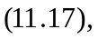

Shear strain 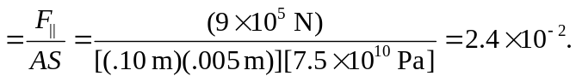

b) Using Equation 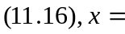 Shear stain 